# **World Population In 2022**

Sravanthi Thukivakam – S559284

## **Introduction**

The aim of this data visualization project is to gain insights into the population dynamics of different countries using a comprehensive dataset. The dataset provides information on various demographic factors such as population size, yearly population change, net change, population density, median age, net migration, fertility rate, urban population percentage, and world share for each country in the year 2022.

The primary objective of this project is to examine and compare population characteristics and demographic indicators across different countries. Through visualizations and statistical analysis, we will delve into the dynamics of population size, land area, net change, population density, median age, net migration, fertility rate, and population growth trends.

By undertaking these visualizations and analyses, we aim to gain valuable insights into the population dynamics, distribution, and trends of different countries. These insights can provide a foundation for further research and informed decision-making in various fields such as urban planning, policy-making, and socio-economic development.

## **Domain Of Dataset**

* Population Statistics and Demographic Indicators.

## **Dataset**

* World Population 2022



## **Data Source**

* Kaggle

<https://www.kaggle.com/datasets/ahmadjalalmasood123/world-population-dataset>

## **Number Of Records And Columns**

* Records: 235
* Columns: 12

1.#: The Ranking of country based of population.

2. Country (or dependency): This column lists the names of different countries or dependencies, such as China, India, United States, etc.

3. Population (2022): This column represents the estimated population of each country or dependency in the year 2022.

4. Yearly change: This column shows the percentage change in population from the previous year to the current year.

5. Net change: This column displays the net change in population, which is calculated by subtracting the number of deaths from the number of births, along with the net migration.

6. Density (P/Km²): This column indicates the population density, which is the number of individuals per square kilometer of land area.

7. Land Area (Km²): This column specifies the total land area in square kilometers of each country or dependency.

8. Migrants (net): This column represents the net migration rate, which is the difference between the number of immigrants and emigrants.

9. Fert. Rate: This column shows the fertility rate, which represents the average number of children born per woman during her reproductive years.

10. Med.Age: This column indicates the median age, which is the age at which 50% of the population is younger and 50% is older.

11. Urban Pop %: This column represents the percentage of the population living in urban areas.

12. World Share: This column shows the percentage of the global population that each country or dependency represents.

## **Visualization Tools Used**

* Tableau
* Excel

## **Data Cleaning Strategies**

* There are blanks in the Migrants column.
* There are NA values in Fert Rate, Med.Age, Urban Pop columns.
* Replaced all blanks and NA values with 0.
* Used Tableau Prep to clean the data and added a cleaning step to complete the above action.

Before Cleaning

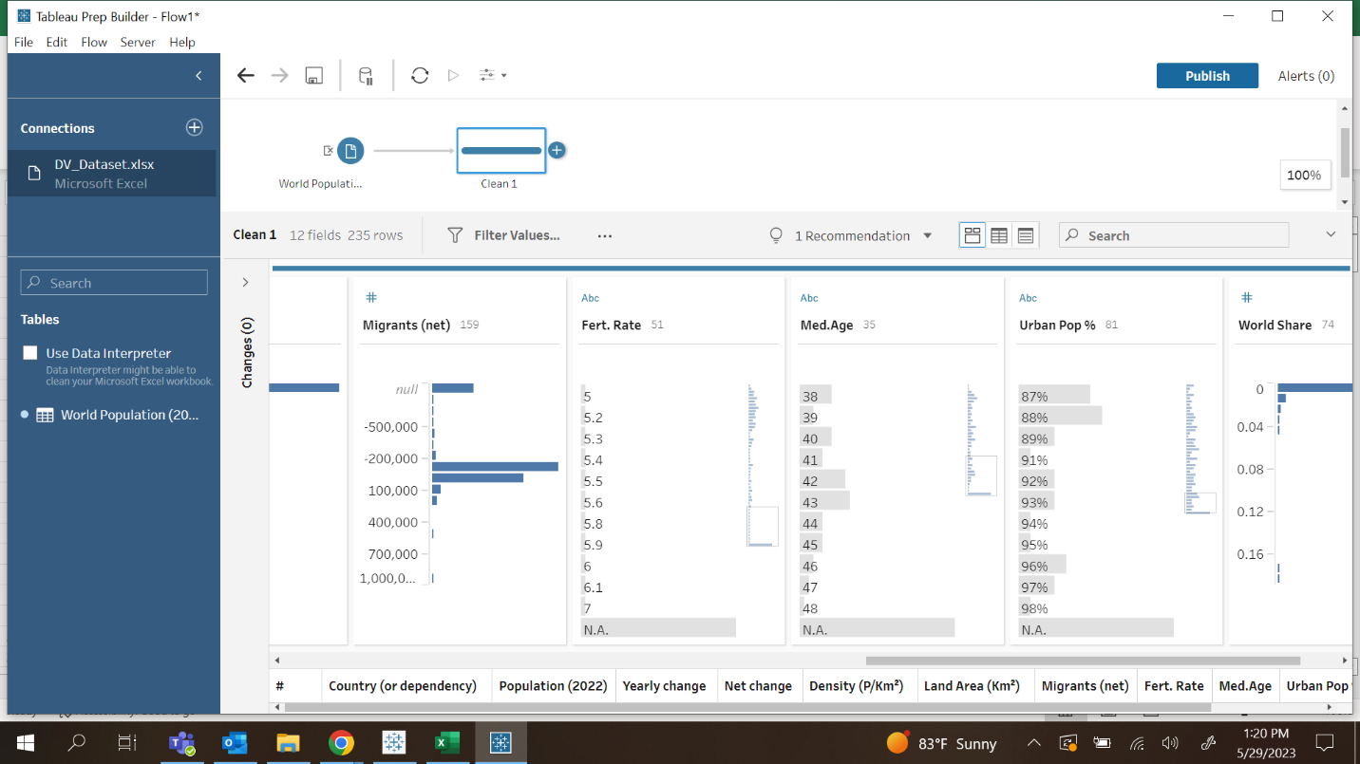

After Cleaning

## **Cleaned Dataset**



## **Goals Of Project**

1. Create a comparison of population sizes for various countries in 2022.
2. Provide a visualization that shows the land area and net change for the top five most populated countries in the world.
3. Analyze and compare the population density of different countries.
4. Analyze the relationship between median age (Med.Age) and net migration (Migrants net) for each country.
5. Analyze how the population density and fertility rate (measured as the number of children born per woman) are related for the top 10 countries?
6. Examine and compare the urban population of different countries specifically in the year 2022.

## **Charts Generated**

1. **GOAL - 1:** Create a comparison of population sizes for various countries in 2022.

Choropleth Map

Symbol Map

**Story:**

The above Choropleth map and symbol map represents the population sizes of different countries in 2022. From the above maps we can infer that China has the highest population that is 1439323776, followed by India that is 1380004385. The countries with least population can be observed in Holy See that is 801.In Choropleth represents the population based on color intensity and symbol map represents the population based on circle sizes.

1. **GOAL - 2:** Provide a visualization that shows the land area and net change for the top five most populated countries in the world.

Area Chart

Side by Side Chart

**Story:**

The area chart and side by side chart represents the land area and net change in 2022 for the five most populated countries in world. Five most populated countries are China, India, United states, Indonesia, and Pakistan. From the area chart we can infer that the net change is high in India but has the significant land area, hence we can conclude that the population is increasing rapidly at the same time the land area is less.

1. **GOAL - 3:** Analyze and compare the population density of different countries.

Filled Map

**Story:**

The above filled map represents the population density across the world in 2022.The highest density is observed in Macao and Monaco that is 21645 P/Km2  and 26337 P/Km2

The least densely populated countries are Australia, Iceland, Falkland Islands. Russia has huge land, but still the density is 9 P/Km2.Each country is represented by a color and the legend shows the density in each country.

1. **GOAL – 4:** Analyze the relationship between median age (Med.Age) and net migration (Migrants net) for each country.

Dual Axis Layer Map

**Story:**

The above Dual Axis Layer map represents the median age and migration in each country. One layer that is Choropleth represents the migrants and another layer symbol represents the median age. The Highest migrants can be seen in the United States and median age is 38. The dark red represents the highest migrants and least orange is least migrants. The big yellow circle means high median and small circle means low median age.

1. **GOAL - 5:** Analyze how the population density and fertility rate (measured as the number of children born per woman) are related for the top 10 countries?

Bubble Chart

Tree Map

**Story**

The above bubble chart and tree maps represent the fertility rate and density in top 10 countries. The bubble represents the density and dark blue represents the high fertility rate. The tree map represents the countries in blocks , highest size of block means high density and the dark blue means high fertility. Bangladesh has the highest density and Nigeria has the highest fertility rate.

1. **GOAL- 6:** Examine and compare the urban population of different countries specifically in the year 2022.

Symbol Map

Story:

The above choropleth and symbol map represent the urban population. The dark blue represents the country with highest urban population and dark red represent country with low urban population. In symbol map each country represents a country and the size represents urban population. Saint Pierre & Miquelon has 100% urban population.

## **Dashboard-1**

## **Dashboard-2**

## **Storyboard**

## **Conclusion**

Project has provided valuable insights into the population dynamics and demographic indicators of various countries. Through comprehensive analysis and visualizations, we have gained a deeper understanding of population sizes, land areas, net changes, population density, median age, net migration, fertility rates, and urban population percentages.

The project revealed the relative population sizes of different countries in 2022, allowing for comparisons and highlighting the most populous nations. The visualization showcasing land area and net change for the top five most populated countries provided a clear understanding of their spatial characteristics and population dynamics.

It is important to note that while this project provides valuable insights, further research and analysis can be conducted to delve deeper into specific aspects of population dynamics and demographic indicators. The dataset used in this project serves as a foundation for future investigations and can be expanded upon with additional data sources and refined methodologies.

Overall, this project contributes to the broader understanding of global population trends, enabling evidence-based decision-making and facilitating informed discussions on addressing population-related challenges and leveraging demographic changes for socio-economic development.